VITALIY KOBETS
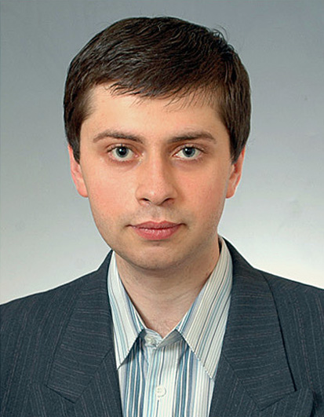
CV

Chair of Computer Science and Economic Cybernetics  Physics, mathematics and computer science  Kherson State University (KSU)  27 40 rokiv Zhovtnya street,  73000, Kherson, Ukraine | Tel.: +38(0552)32-67-82, +38(0552)32-67-68  Emails: vkobets@kse.org.ua, kobetz@ukr.net  Web: http://www.ksu.ks.ua

EDUCATION
January, 2011 | Associate Professor
October, 2008 | PhD (Economics)  Specialty: 08.00.11 – Mathematical methods, models and information technologies in economics  Theme: Economical and mathematical modeling of producer and transport systems under informative symmetry and asymmetry
January, 2004 – December, 2008 | Post-graduate student, Odessa National Marine University
September, 2002 - June, 2003 | Master Degree (mathematics), Kherson State University (with high honor)
June, 1995 –  June 1997 | Academic Liceum of KSU

RESEARCH FIELD
Microeconomics, industry economics, public sector economy, economic mechanism theory, dynamic economic systems, evolutionary economics

PUBLICATIONS
Scopus papers
(Author ID: 56006224700, http://orcid.org/0000-0002-4386-4103):
- Vitaliy Kobets, Valeria Yatsenko, Maxim Poltoratskiy. Dynamic model of double electronic Vickrey auction . In: Proc. 11th Int. Conf. ICTERI 2015. Lviv. Ukraine. May 2015. CEUR-WS vol. 1356. pp. 236-251.
- Kobets V., Poltoratskiy M. Forming an Evolutionarily Stable Firm Strategy under Cournot Competition Using Social Preferences, Springer: Lecture Notes in Computer Science. - 2014.
- Kobets V.М. Incentive compatible mechanism design of custom policy for complex social choice function. Actual Problems of Economics (Thomson Reuters, Sci Verse Scopus, Index Copernicus, EIBSOhost, Ulrich's Periodicals Directory, EconLit). – 2014. – № 6(156). – P. 478-486.
- Vitaliy Kobets. Mechanism Design for Foreign Producers of Unique Homogeneity Product. In: Proc. 9th Int. Conf. ICTERI 2013. Kherson. Ukraine. June 2013. CEUR-WS vol. 1000. pp. 329-338.
- Ermolayev, V., Mayr, H.C., Nikitchenko, M., Spivakovsky, A., Zholtkevych, G., Zavileysky, M., Kobets, V. Preface (2012). CEUR Workshop Proceedings, vol. 848, PP. 3-4 (Indexed by: Sci Verse Scopus, DBLP, Google Scholar).
- Kobets, V., Kryukov, S., Payentko, T. Foreword (2012). CEUR Workshop Proceedings, vol. 848, P. 258 (Indexed by: Sci Verse Scopus, DBLP, Google Scholar).
- Kobets, V. Direct and indirect impact analysis of ukrainian industries on gross output and labor market in leontief model (2012), CEUR Workshop Proceedings, vol. 848, PP. 259-266 (Indexed by: Sci Verse Scopus, DBLP, Google Scholar).
- Kobets, V.М. Tariff policy of transport company-monopolist at delivery of products of m producers to n markets. Actual Problems of Economics (Thomson Reuters, Sci Verse Scopus, Index Copernicus, EIBSOhost). – 2011. – № 5(95). – С. 263-271.

TEACHER EXPERIENCE
June 2011 – present | Deputy head of Computer Science and Economic Cybernetics Chair
June, 2008 – present | Associate Professor, KSU
September, 2007 – December 2008 | Senior teacher of Economics Chair, KSU
August, 2002 – January, 2007 | Assistant of Economics Chair, KSU

PEDAGOGICAL ACTIVITY
Microeconomics, industry economics, statistics, econometrics, business process modeling.

TRAINING, PROJECTS, SCHOLARSHIP
2015 | Project ERASMUS+ 561592-EPP-1-2015-1-FR-EPPKA2-CBHE-JP-Establishing Modern Master-level Studies in Information Systems (2016-2018)
2014 | High School of Economics (HSE), distance course COURSERA «Industry economics», high honor certificate
2012-2015 | Head of International Workshop «ІТ in economic research» of conference ICTERI 2013, 2014, 2015 http://www.icteri.org/page/workshop-iter
2011, 2015 | Kherson National Technical University,  Theme of training: «Economic dynamic modeling» (2011), «Business process modeling» (2015)
2009-2010 | scientific adviser of project «Development of integrated control knowledge system of students for economic and math courses for universities of economic specialties» (no. 0109 U 006320)
2009-2010 | State University of New York (SUNY), distance course MGMT 395 «International business communications»
2007-2008 | Kyiv School of Economy, Consortium of economic education and research (EERC), High Educational Support Program (HESP)
2006-2007 | Odessa National Polytechnic University, course of tutor for distance learning
2005-2006 | National University «Kyiv-Mohyla Academy» (NAUKMA)
2002 | Coimbra University (Portugal), Economic Department, Program TEMPUS-TACIS Network training “Europe–Black Sea” (M-JEP-21224-2000)
2002 | Munitipal scholarship
2001-2002 | Kherson State University, English courses (business communications)

